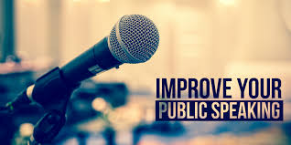
Public Speaking & Debate Workshop Series

CONFIDENCE: Maintaining eye contact, volume, and enunciation.
PASSIONATE: Keeping the audience engaged, using gestures effectively, and pacing through the speech.
LOGICAL: Organizing arguments, and making a point clear and coherent.

Effective speaking is a skill. This series of workshops provides structure for discussion, debate, and creating and delivering powerful presentations. The program focus is coaching you to command the attention and interest of an audience by practicing all of the essential elements of successful public speaking.
Outcomes
- Participants will learn the strategies to outline their speeches and to judge the credibility of source material, the ways to cite sources in their speeches, and how to gain and hold the attention of an audience
- Participants will learn effective discussion techniques for use in the classroom
- Lessons are dynamic and highly interactive, with heavy emphasis on peer evaluation and self-reflection
- We will work towards a culmination TED-style talk in which friends, family, and community will be invited to an evening of speeches

Workshop facilitator: Al Schleicher is a secondary school teacher from Los Angeles, CA. A licensed English teacher with a M.A. in Secondary Education, Al teaches 10th grade English and he is a Speech & Debate coach. A member of the National Speech & Debate Association honor society and the National Council of Teachers of English, Al has taught public speaking and debate for seven years. He is the recipient of the 2016-2017 Fulbright Distinguished Award in Teaching.

